Executive Brief

The New Face of Insider Risk
Trusted access has changed. Insider risk programs need to change with it.

Most security stacks are not broken. They do what they were designed to do. The challenge is that insider risk also requires understanding the person behind trusted access.

Trusted access is more complex
Employees, remote workers, contractors, stolen and synthetic identities, and increasingly AI tools and agents can all operate with trusted access. Traditional security controls remain essential, but they do not provide the entire picture. Insider risk also requires relevant human context and a governed way to get that information to the people responsible for managing risk.

The numbers make the case
$19.5M  AVERAGE ANNUAL COST  per organization across insider incidents in 2025 |  | 53%  NEGLIGENT OR MISTAKEN  share of 7,490 incidents in the study |  | 67 DAYS  AVERAGE CONTAINMENT  only 13% were contained within 30 days
2026 Ponemon Institute Cost of Insider Risks Global Report, sponsored by DTEX. Study population: 354 organizations that had experienced one or more material insider incidents.

AI is widening the governance gap
The 2026 study found that 92 percent of organizations say generative AI has changed how employees access and share information, while only 18 percent have fully integrated AI governance into their insider risk programs. AI is changing both how people work and how trusted identities operate inside organizations.

Human risk requires context, not surveillance
Financial difficulty, legal problems, relationship disruption, employment actions, grievances, and other significant stressors can become relevant when combined with concerning behavior. No single factor predicts violence or makes someone an insider risk. The objective is not to label an employee because they are having a difficult year. It is to recognize when multiple indicators warrant a fair, informed assessment and an opportunity to intervene.

Connect the signals. Understand the context. Act earlier.
An effective insider risk model connects relevant human and technical information, validates what matters, and gives the appropriate risk owners the context needed to respond. Technical controls remain essential. Human risk information adds another layer of context around the person behind the access.
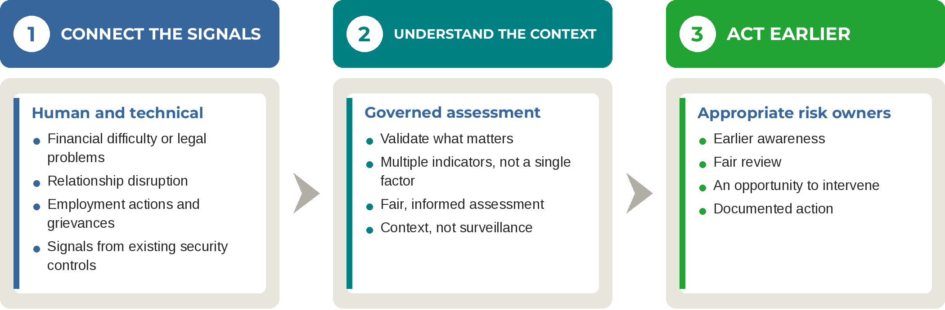
The goal is not more alerts. It is earlier awareness, fair review, and documented action.

Questions leadership should be able to answer
 Who has the authority to bring together relevant HR, security, cyber, and legal information?
Is AI governance integrated into the insider risk program?
Are intervention thresholds defined, with clear ownership and a documented response process?
Can the hiring process detect the use of a valid but stolen identity, and what happens if one is already on the payroll?

Build trust before you need it.
ClearForce Resolve helps organizations connect relevant human risk signals with governed assessment and documented action.
Learn more at www.ClearForce.com

Read the Full Paper  The New Face of Insider Risk  Why Trusted Access, Artificial Intelligence, and Point-in-Time Controls Call for a Governed, Human-Centered Approach  Explore the research, real-world cases, governance framework, and practical steps organizations can take to identify relevant human risk earlier and respond responsibly.  Download the Full Paper › |  | Learn more about ClearForce Resolve  ClearForce Resolve  See how ClearForce helps organizations connect relevant human risk signals with existing security programs to support earlier awareness, informed assessment, and documented action.  Learn More About Resolve ›
Selected sources
- Ponemon Institute, 2026 Cost of Insider Risks Global Report, sponsored by DTEX.
- Federal Bureau of Investigation, workplace violence and behavioral threat-assessment guidance.
- U.S. Bureau of Labor Statistics, Census of Fatal Occupational Injuries, 2024.

